Bespoke and Repurposing

We work closely with the client to establish design goals, beginning with an interview to ascertain their personal needs and desires, their personal style and taste, and preferences in material and technique.

We strive to develop a piece that will grace the wearer, and resonate with them, while creating something fresh in design and interesting to make.

After establishing design goals, we do a series of sketches, which allows us to develop design concepts and explore possibilities and refine our understanding of the client’s desires for the piece.

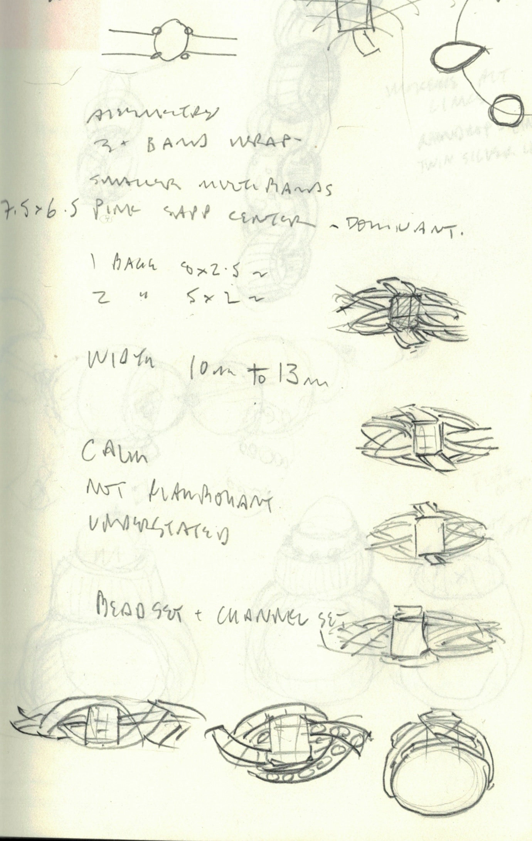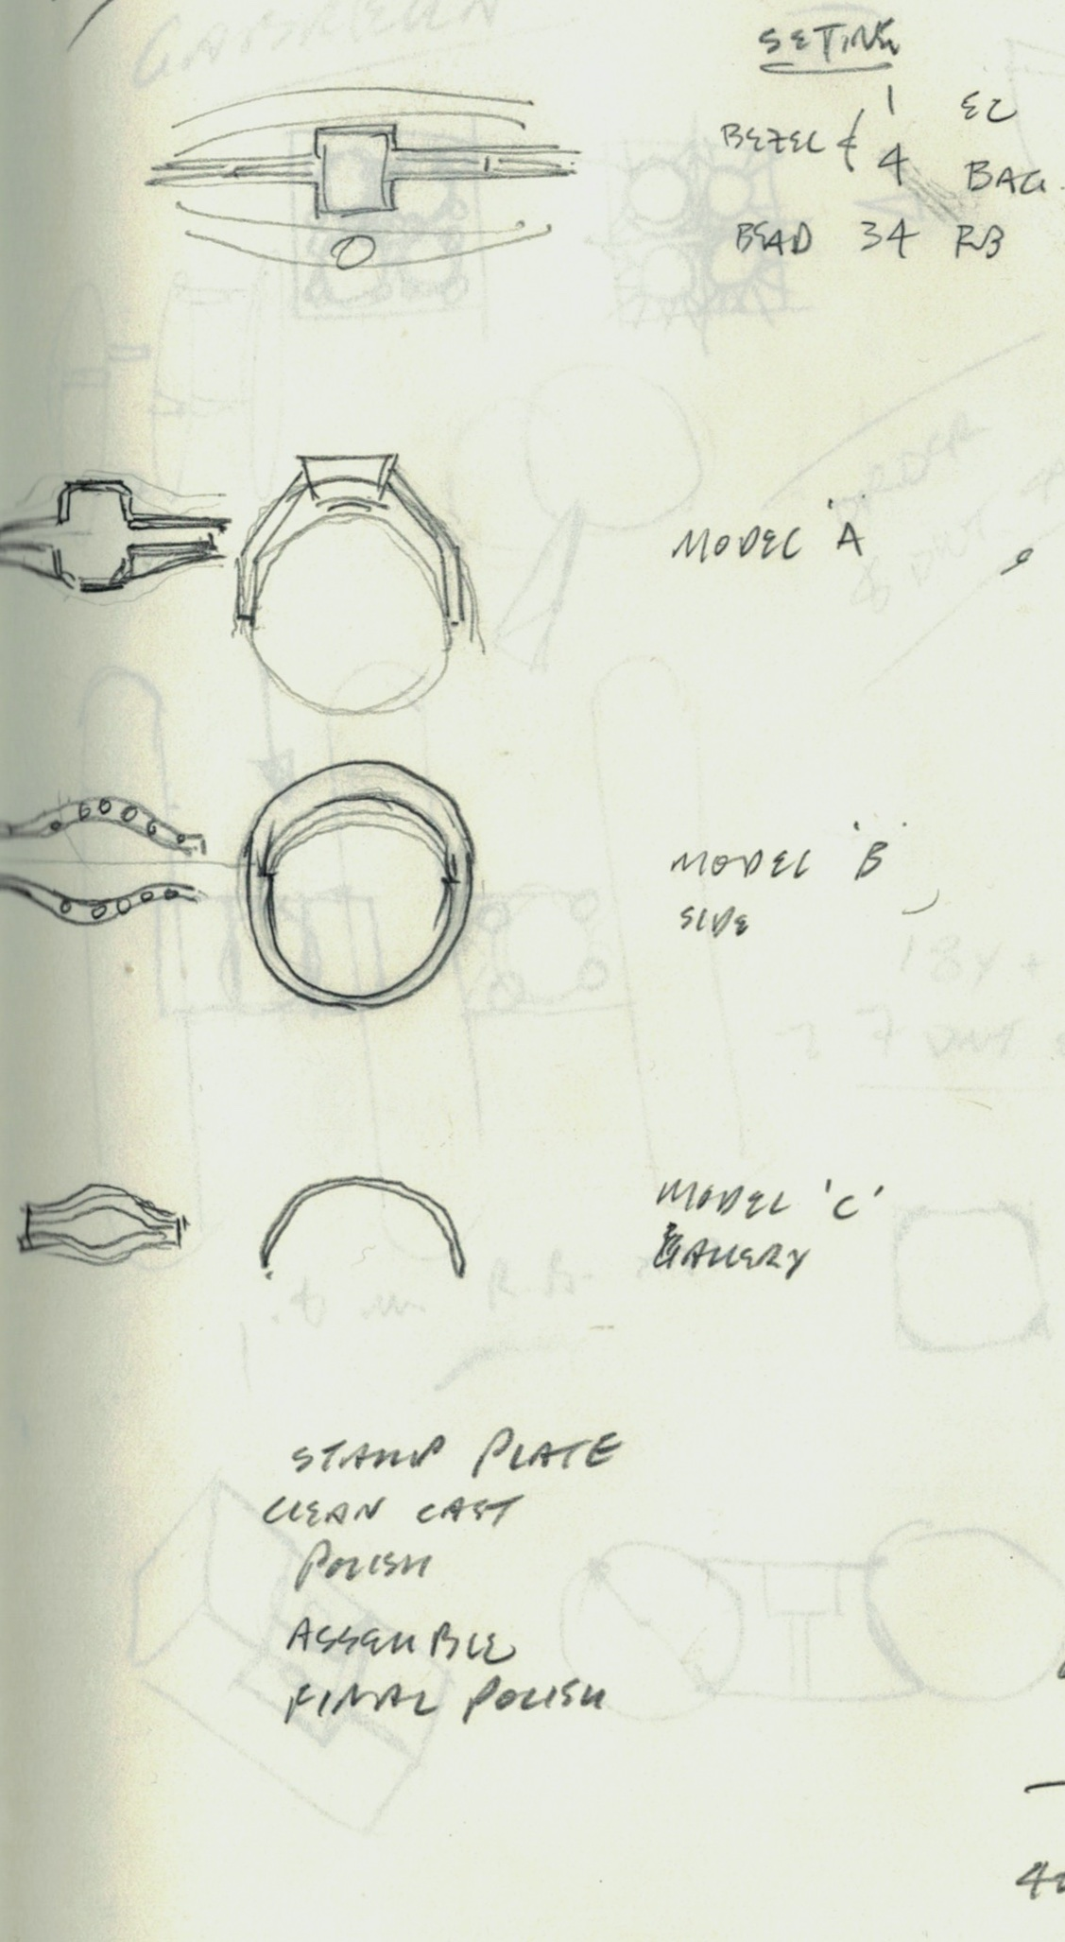

The next step is to produce a mock-up to solve geometry including the proportion, topography, placement of stones, and to refine the layout of the gemstones. 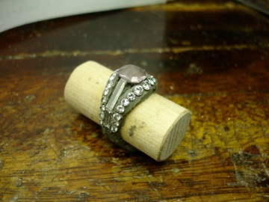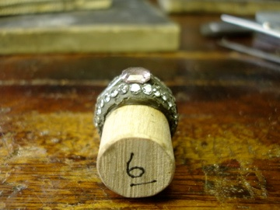

After the layout is approved by the client, they are presented with final design in the form of a gouache rendering.

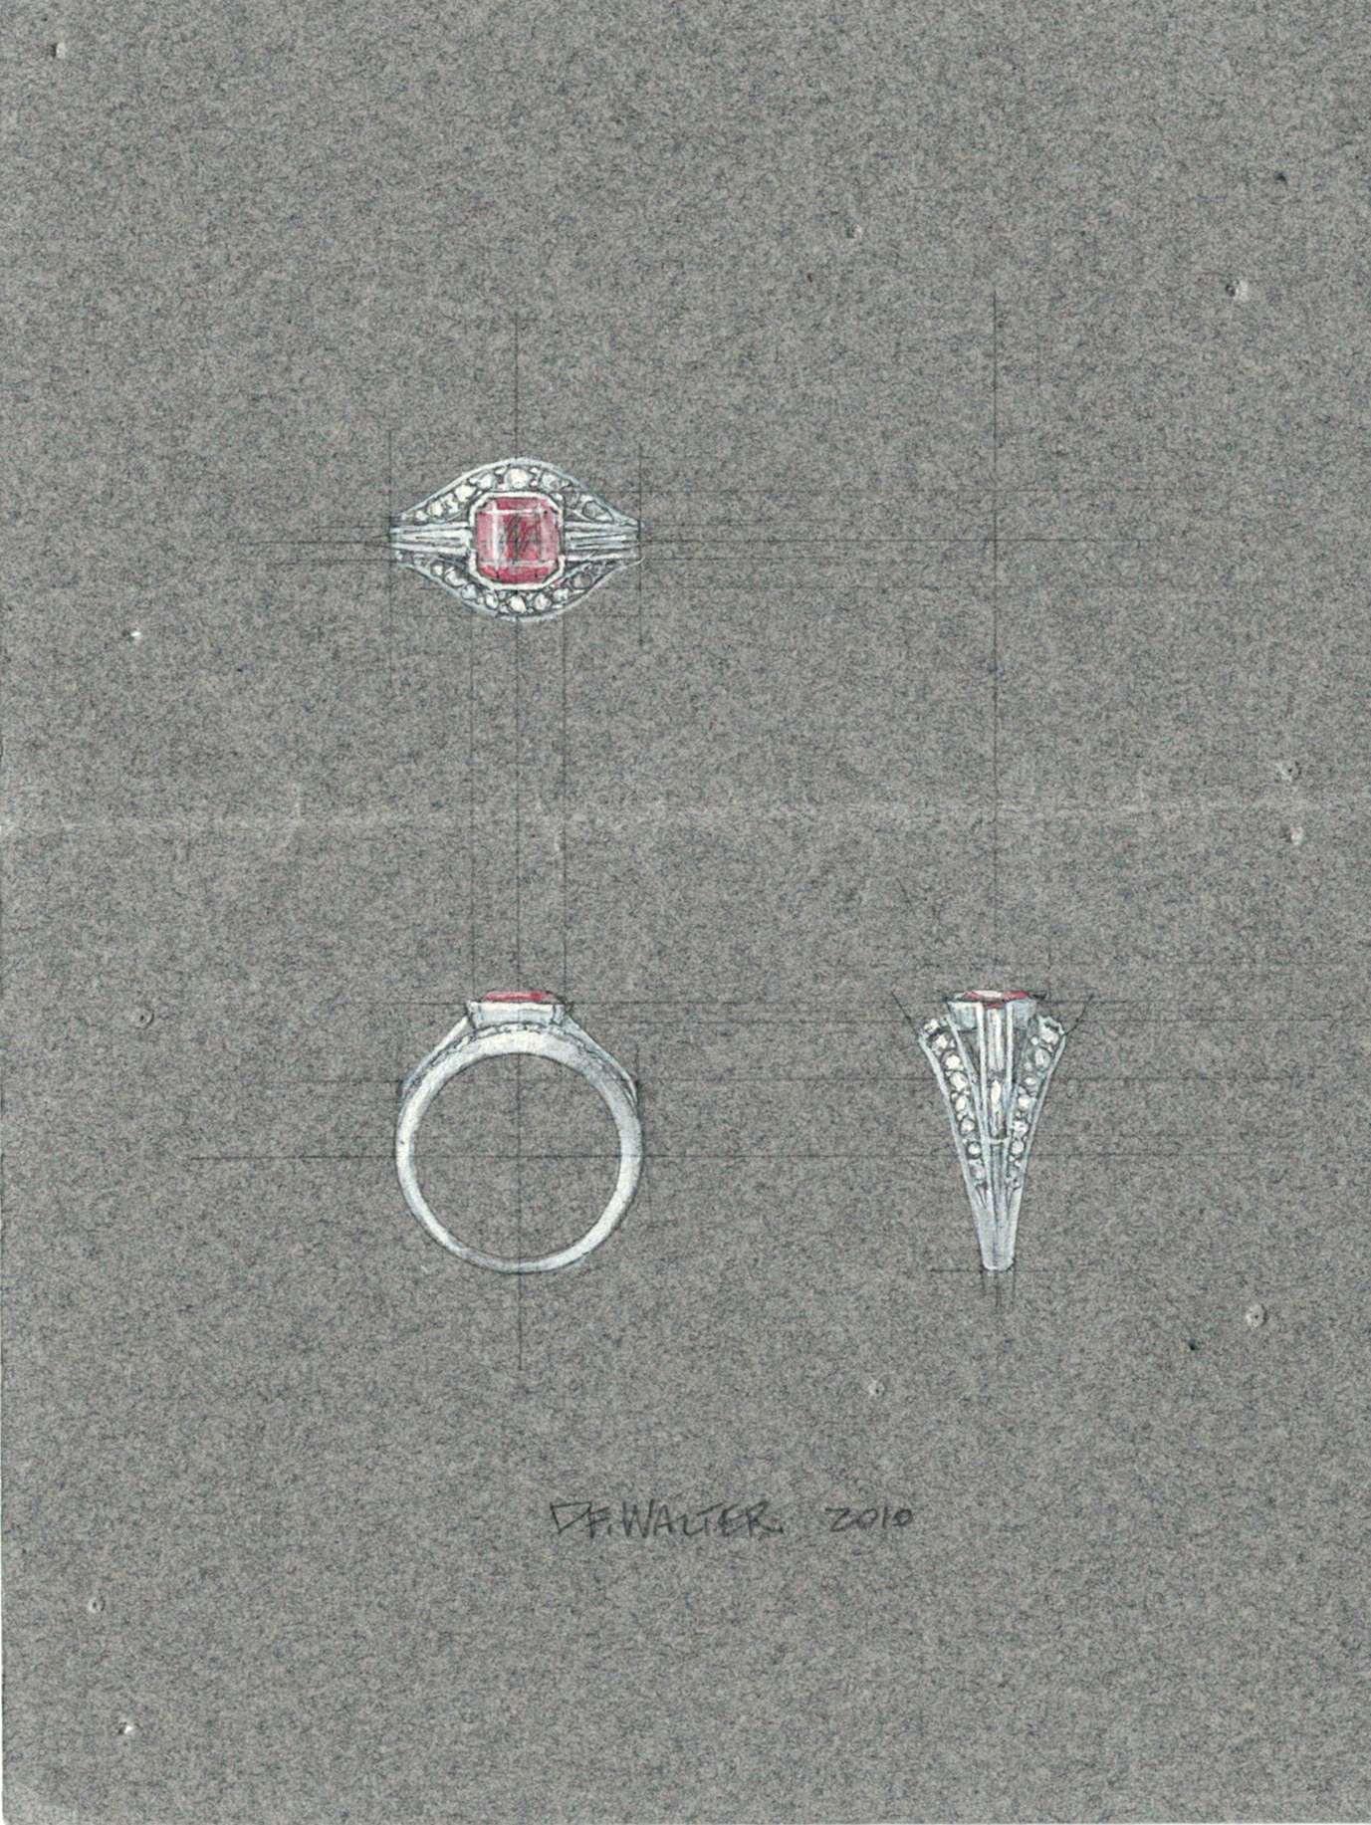

Production takes place in our Southern Vermont studio according to the design objectives and materials chosen. Some clients like to visit their piece while it’s in production in order to deepen their understanding of our process.

Each piece we create is contemporary heirloom, to be enjoyed for generations and represents a marriage of our design aesthetic, impeccable craftsmanship, and our client’s vision.

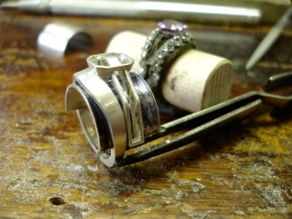

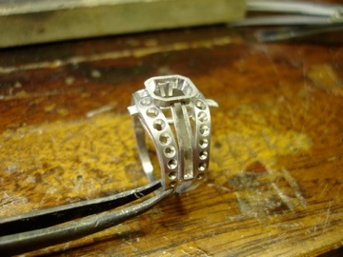

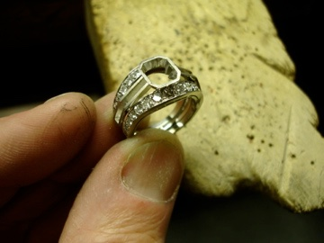

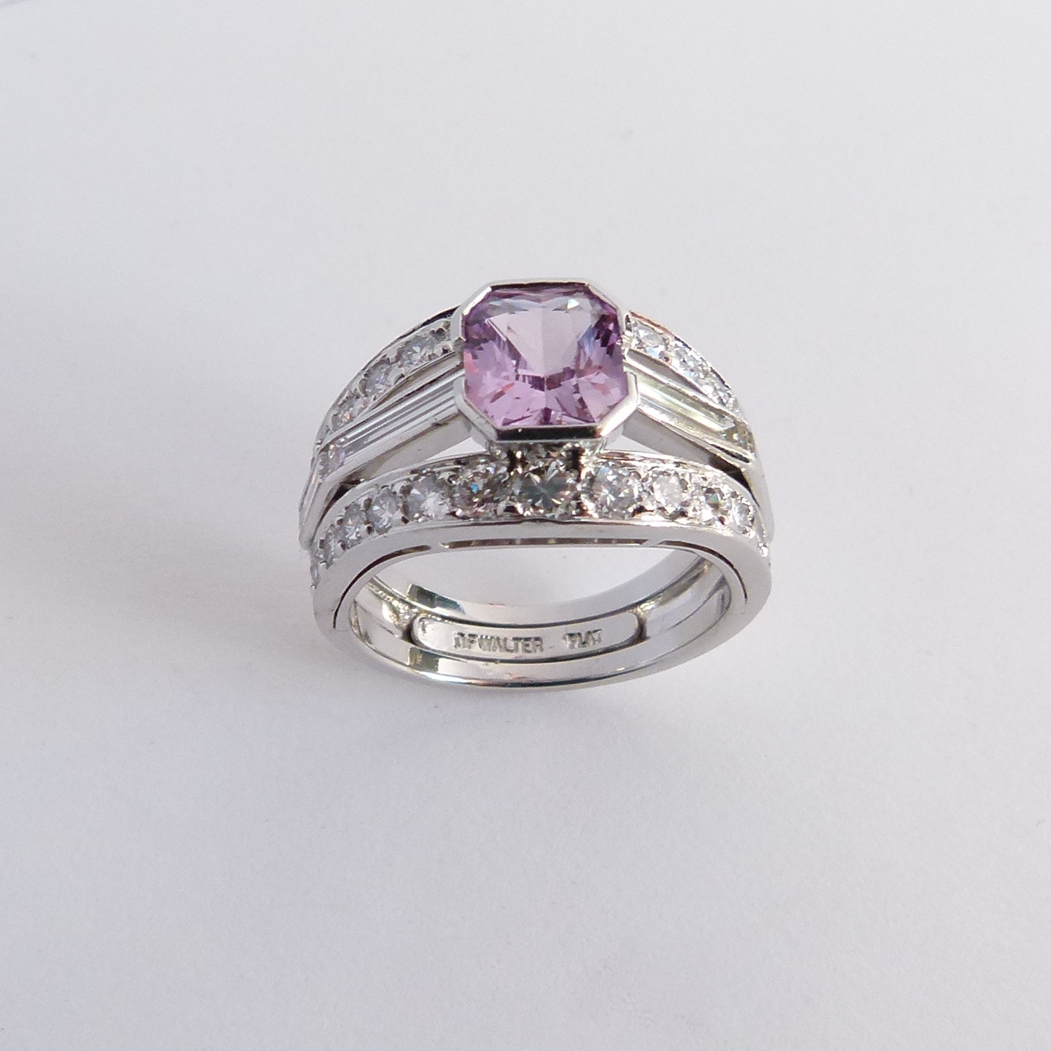

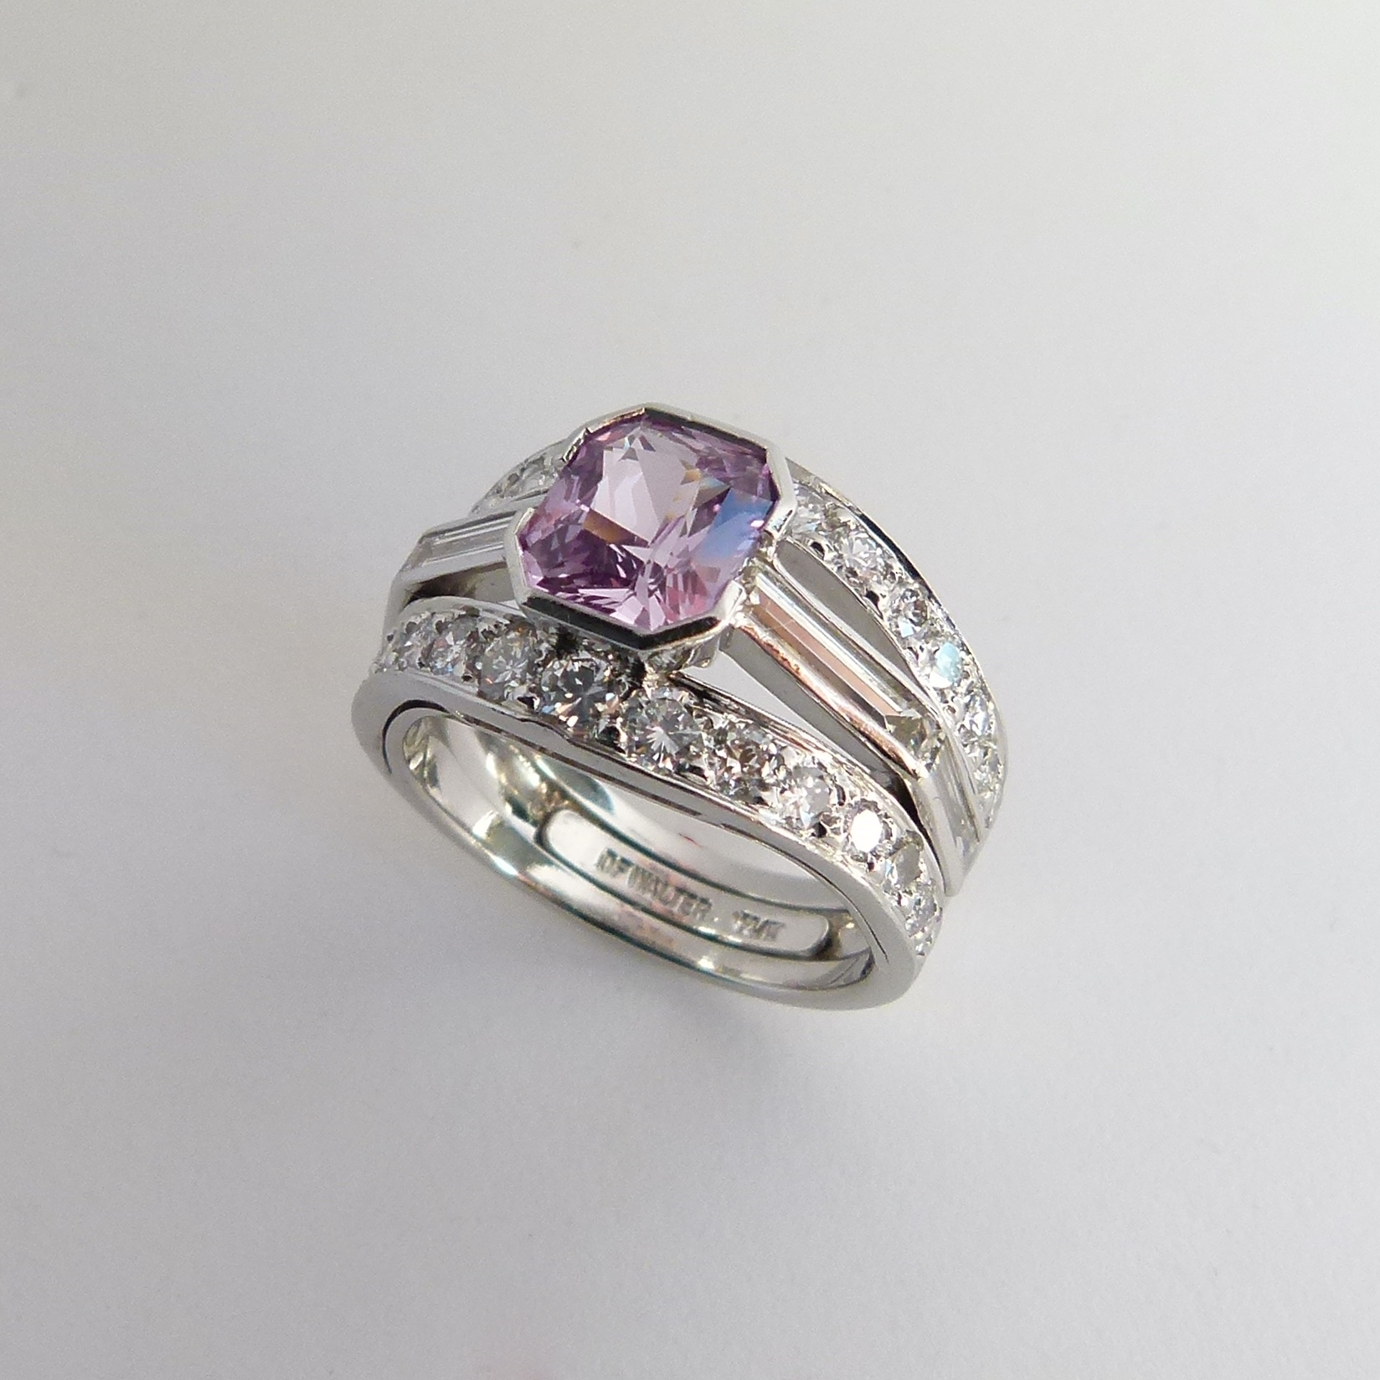

For a detailed account of the production of this piece please visit our blog at dfwalter.com/blog

Each piece we create is contemporary heirloom, to be enjoyed for generations and represents a marriage of our design aesthetic, impeccable craftsmanship, and our client’s vision.